**BIOL1020 Practical 6 Worksheet – Eukaryotic Genetics**

Name: __________________ Session & Tutor: ______________________

**Card A:**

**1.1** Will you treat this as monohybrid or a dihybrid cross? Explain your answer.

**1.2** Which allele is dominant for Card A? Explain how you know.

**1.3** What is the genotype of the F1 for Card A?

(Use R and r as your allele symbols.)

**1.4** Draw a Punnett square showing the results of crossing your F1 to obtain F2 for Card A.

**1.5** What are the phenotypes and expected ratios for F2?

**2.1** Actual F2 phenotype count:

**Card B:**

|  |  |  |
| --- | --- | --- |
| Phenotype |  |  |
| Count |  |  |
| Total |  |  |

**1.1**. Will you treat this as monohybrid or a dihybrid cross? Explain your answer.

**1.2**. Which allele is dominant for Card B? Explain how you know.

**1.3** What is the genotype of the F1 for Card B?

(Use Su and su as your allele symbols.)

**1.4** Draw a Punnett square showing the results of crossing your F1 to obtain F2 for Card B.

**1.5** What are the phenotypes and expected ratios for F2?

**2.1** Actual F2 phenotype count:

|  |  |  |
| --- | --- | --- |
| Phenotype |  |  |
| Count |  |  |
| Total |  |  |

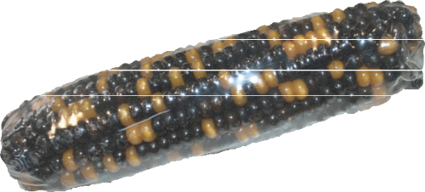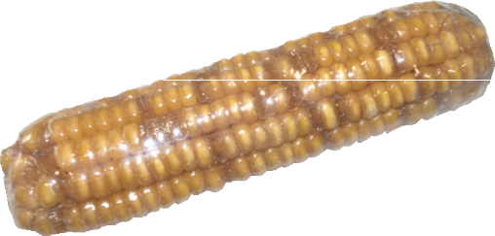

**2.2** What evidence do you have that the phenotypes you are investigating are actually being inherited, rather than resulting from environmental effects? (i.e. How do you know?)

**2.3** State, as completely as you can, your hypothesis about the inheritance of the phenotypes.

**Exercise 3:**

* 1. Use the given results for different cobs (Appendix) to calculate the Chi-square values for Card A. (You need to use the table & calculations separately for **each** cob. **Do not** total the counts for all cobs).

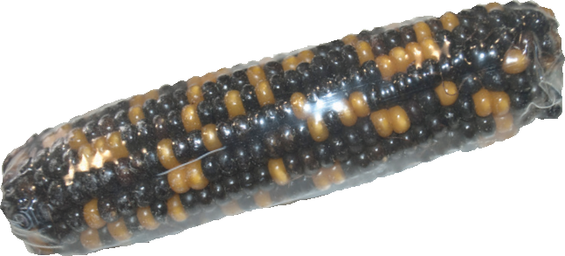

|  |  |  |  |
| --- | --- | --- | --- |
|  | Phenotype 1 | Phenotype 2 | Sum |
| Observed (O) |  |  |  |
| Expected (E) |  |  |  |
| (O – E) |  |  |  |
| (O – E)2 |  |  |  |
| (O – E)2/E |  |  |  |

* 1. Add them to the Chi-square values column on your Data Table (Appendix or Corn Data worksheet).
  2. Use the given results for different cobs (Appendix) to calculate the Chi-square values for Card B.

|  |  |  |  |
| --- | --- | --- | --- |
|  | Phenotype 1 | Phenotype 2 | Sum |
| Observed (O) |  |  |  |
| Expected (E) |  |  |  |
| (O – E) |  |  |  |
| (O – E)2 |  |  |  |
| (O – E)2/E |  |  |  |

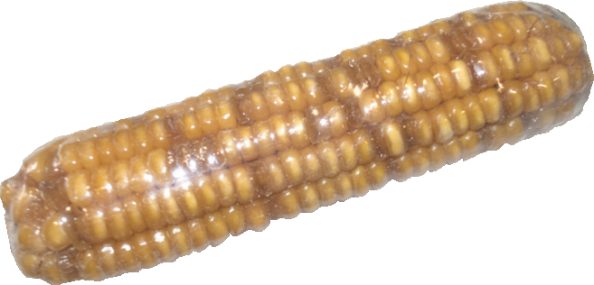

**3.4** Add them to the Chi-square values column on your Data Table (Appendix or Corn Data worksheet).

**3.5** Do you think any of the data is significantly different to the expected ratio? If so, explain why you think so.

**Exercise 4 (Card C):**

**4.1** Will you treat this as a monohybrid cross or a dihybrid cross? Explain your answer.

**4.2** Give the genotypes and the phenotypes of the two parents, A-1 and B-1.

**4.3** Give the genotypes and the phenotypes of the F1 (Cob C). (Construct a Punnett square to help you.)

**4.4** Construct a Punnett square showing the results of crossing the F1 to obtain F2 offspring.

**4.5** What are the genotypes and expected ratios of the F2?

**4.6** What are the phenotypes and expected ratios of the F2?

**Exercise 5:**

**5.1** Actual F2 phenotype count:

|  |  |  |  |  |
| --- | --- | --- | --- | --- |
| Phenotype |  |  |  |  |
| Count |  |  |  |  |
| Total |  |  |  |  |

**5.2** Use the given results for different cobs (Appendix) to calculate the Chi-square values for Card C. (As before, you need to use the table & calculations separately for **each** cob. **Do not** total the counts for all cobs).

|  |  |  |  |  |  |
| --- | --- | --- | --- | --- | --- |
|  | Phenotype 1 | Phenotype 2 | Phenotype 3 | Phenotype 4 | Sum |
| Observed (O) |  |  |  |  |  |
| Expected (E) |  |  |  |  |  |
| (O – E) |  |  |  |  |  |
| (O – E)2 |  |  |  |  |  |
| (O – E)2/E |  |  |  |  |  |

**5.3** Add them to the Chi-square values column on your Data Table (Appendix or Corn Data worksheet).

**5.4** Calculate the degrees of freedom for this experiment.

**5.5** Do you think your data is significantly different to the expected ratio? Explain why or why not.

**Exercise 6:**

**6.1** If the genotype of your purple cob is homozygous for colour (R), show all possible gametes it could produce.

**6.2** If the genotype of your purple cob is heterozygous, show all possible gametes it could produce.

**6.3** For the yellow cob, show all possible gametes it could produce.

**6.4** Draw Punnett squares to show all possible results of crossing purple with yellow.

Homozygous (RR)

|  |  |  |
| --- | --- | --- |
| Gametes |  |  |
|  |  |  |
|  |  |  |

Heterozygous (Rr)

|  |  |  |
| --- | --- | --- |
| Gametes |  |  |
|  |  |  |
|  |  |  |

**6.5** Give the possible genotypes and phenotypes of these crosses.

Homozygous (RR)

|  |  |
| --- | --- |
| Genotype | Phenotype |
|  |  |
|  |  |

Heterozygous (Rr)

|  |  |
| --- | --- |
| Genotype | Phenotype |
|  |  |
|  |  |

**6.6** What is the expected phenotype ratio of each cross?

**6.7** What is the difference observed in the offspring of the homozygous dominant parent compared to the heterozygous parent?

**6.8** If the genotype of your purple, plump cob is homozygous for both traits (R & Su), show all possible gametes it could produce.

**6.9** If the genotype of your purple, plump cob is heterozygous for both traits, show all possible gametes it could produce.

**6.10** For the yellow, wrinkled cob, show all possible gametes it could produce.

**6.11** Draw Punnett squares to show all possible results of crossing purple, plump with yellow, wrinkled.

Homozygous (RR SuSu)

|  |  |  |  |  |
| --- | --- | --- | --- | --- |
| Gametes |  |  |  |  |
|  |  |  |  |  |
|  |  |  |  |  |

Heterozygous (Rr Su su)

|  |  |  |  |  |
| --- | --- | --- | --- | --- |
| Gametes |  |  |  |  |
|  |  |  |  |  |
|  |  |  |  |  |

**6.12** Give the possible genotypes and phenotypes of these crosses.

Homozygous (RR SuSu)

|  |  |
| --- | --- |
| Genotype | Phenotype |
|  |  |
|  |  |
|  |  |
|  |  |

Heterozygous (Rr Su su)

|  |  |
| --- | --- |
| Genotype | Phenotype |
|  |  |
|  |  |
|  |  |
|  |  |

**6.13** What is the expected phenotype ratio of each cross?

**6.14** What is the difference observed in the offspring of the homozygous dominant parent compared to the heterozygous parent?